1. Specify the location where all input csv files are stored

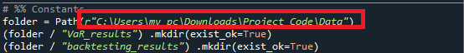

1. Code will create two folders – In case folders are already existing then it will skip this step
   1. “VaR_results” – To store output VaR results
   2. “backtesting_results” – To store output Backtesting results



1. Define the start date of time window for VaR computation.

By default, it is defined as 1st January 2005 (2005, 1, 1)

Start_date = pd.Timestamp(2005, 1, 1)



1. Define the start date of time window for backtesting computation.

By default, it is defined as 1st January 2006

backtesting_start_date = pd.Timestamp(2006, 1, 1)



1. Define the window size (time window size).

By default, it is defined as 250 business days



1. Define holding period, confidence interval for VaR and ES

For our project we have chosen following

Holding period (hp =1) = 1 business day => 1-day VaR

Confidence Interval for VaR (ci_var = 0.99) = 99%

Confidence interval for ES (ci_es = 0.975) = 97.5%



Alpha is computed as 1- confidence interval